NEGATIVE PRESSURE UNIT AIR-PRO/2000H
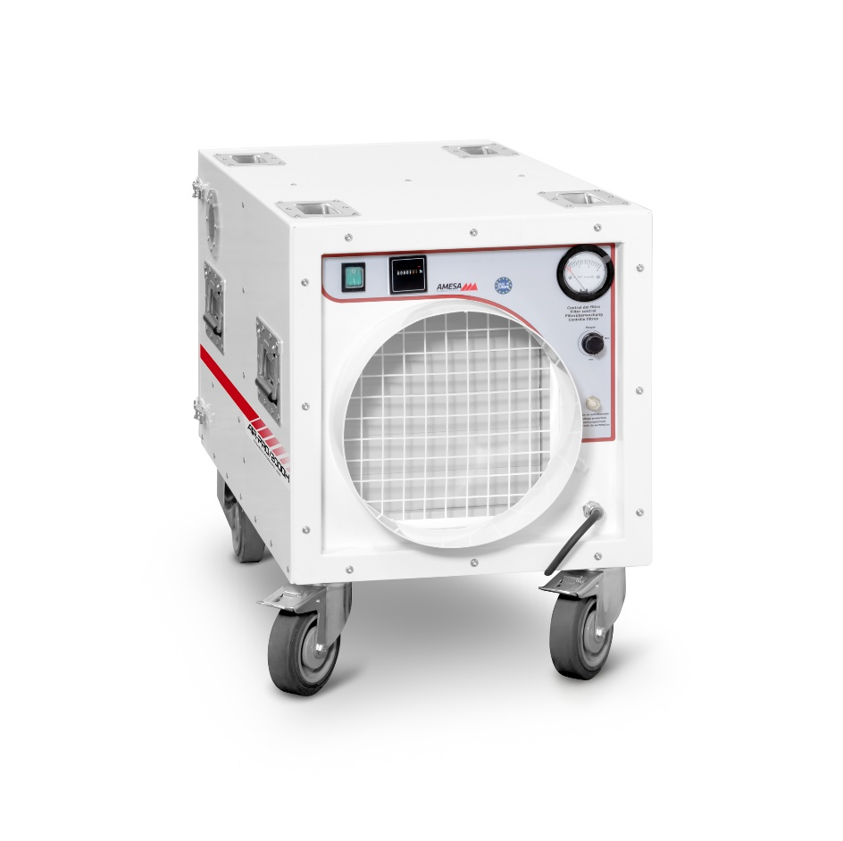
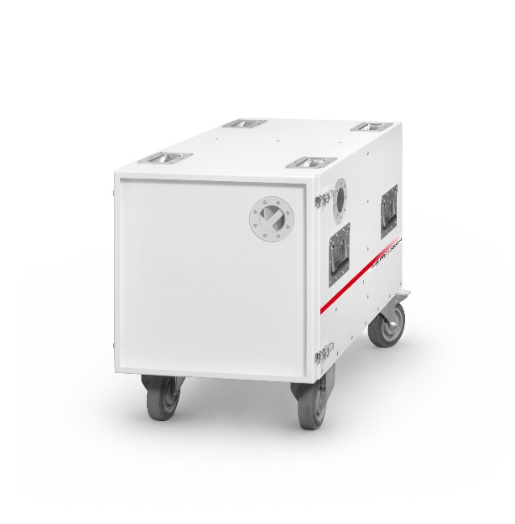
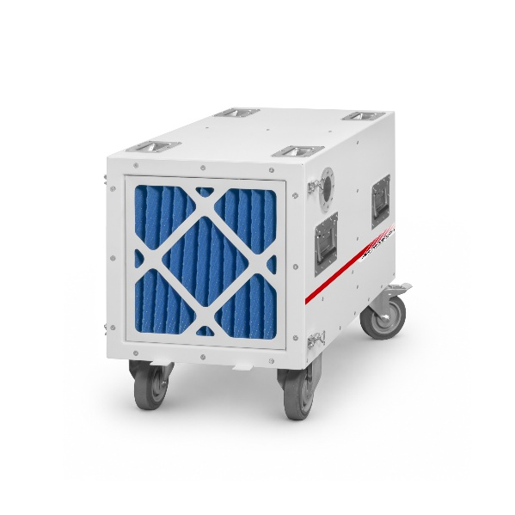

DESCRIPTION:
Negative Pressure Unit, designed to maintain negative pressure in asbestos removal activities.
The housing, front panel, and rear cover are made of powder-coated aluminum, making the unit lightweight and durable. It is specially designed for long-term use and for ease of handling.

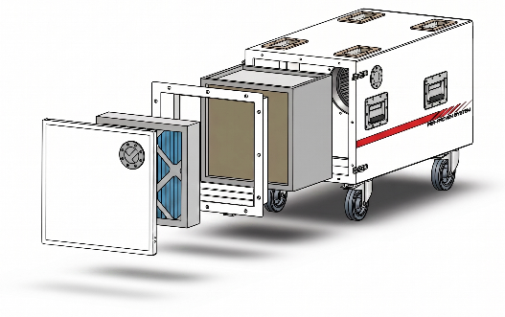
FEATURES:
- Nominal airflow capacity of 2000 m³/h
- Variable flow control
- Automatic soft start
- HEPA filter H14: 99.995% filtration

- PU-coated nylon wheels, Ø125 mm, includes 2 brakes

TECNICAL DATA: Fan characteristics:
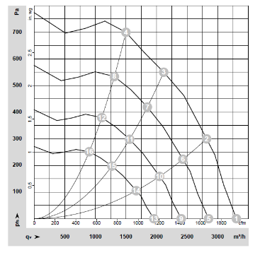
- Dimensions (LxWxH): 840x465x610 mm
- Weight: 32 kg
- Power supply: 230 Volt, 50 Hz
- Operating current: 2,2 A
- Motor power: 0,5 kW
- Exhale hose connection: Ø300 mm
- 2-step filter system:
Pre-filter EU4: 373x373x94 mm
HEPA filter acc. to EN 1822 Class H14: 380x380x292 mm

